TURBEX ELMASONIC X-TRA PRO-1600 Ultrasonic cleaner

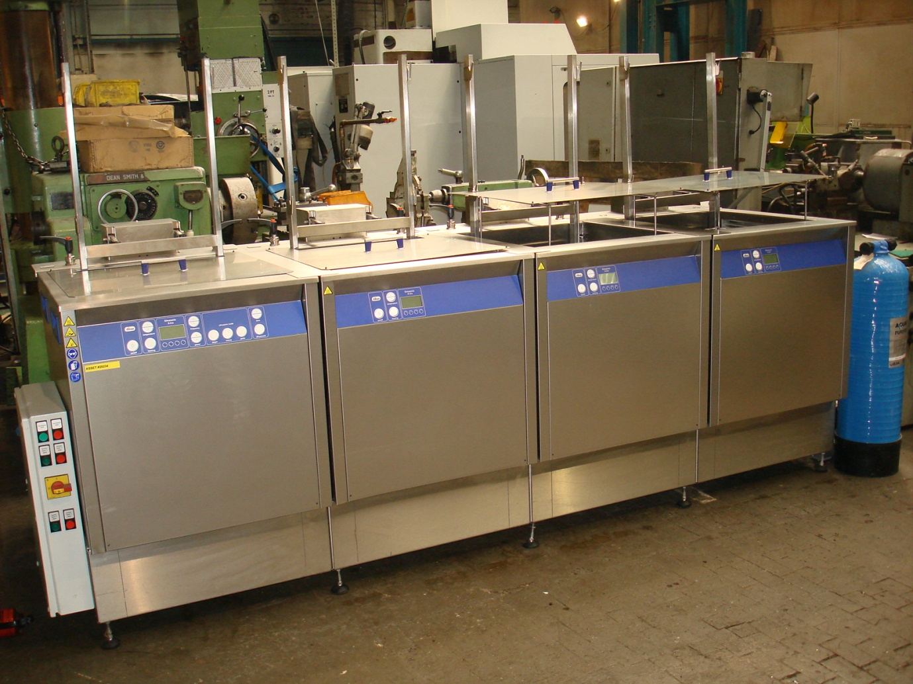

Type Pro 1600 Elma Control

This machine is;
- approaching 4 years old
- The process is
  - ultrasonic wash
  - heated rinse
  - heated rinse
  - hot air dry

2 x Basket Dims 524 mm x 438mm x 360 mm (LxWxH)

2 x Water tanks

£POA

